Biology Unit 10 Classification

10:1 Classification and Taxonomy
CLASSIFICATION:
TAXONOMY:
TAXON:

DICHOTOMOUS KEY:
- Characteristics are given in _____________________
- Read both _____________________ and either go to ____________
Set of characteristics OR ________________________ the organism

Dichotomous Key of Leaves
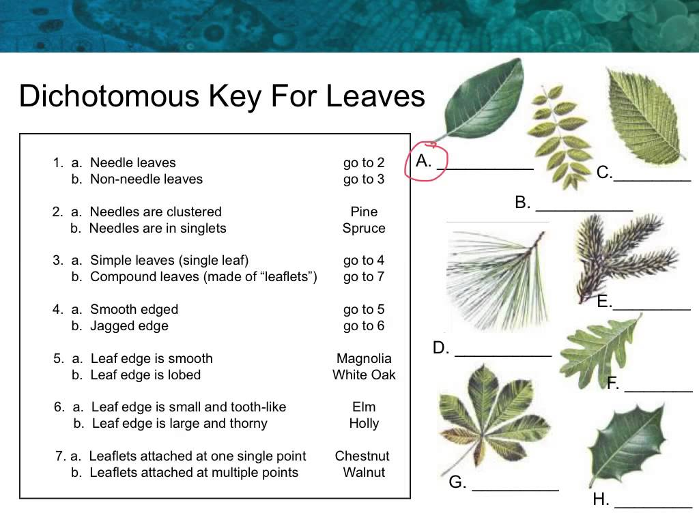
10:2 Development of Taxonomy
- A natural way of classifying organisms is based on the way ________________________________________________________.
- About 2,400 years ago, _____________ classified organisms into only two _________ --___________ or ________________.
- Swedish botanist ____________________________ developed a classification system based on__________________________ during the 1700s.

Linnaeus divided all organisms into two major groups called which he divided into smaller and smaller groups.

LESS SPECIFIC

MORE SPECIFIC

DOMAIN: ___________________________________________________
____________________________________________________________
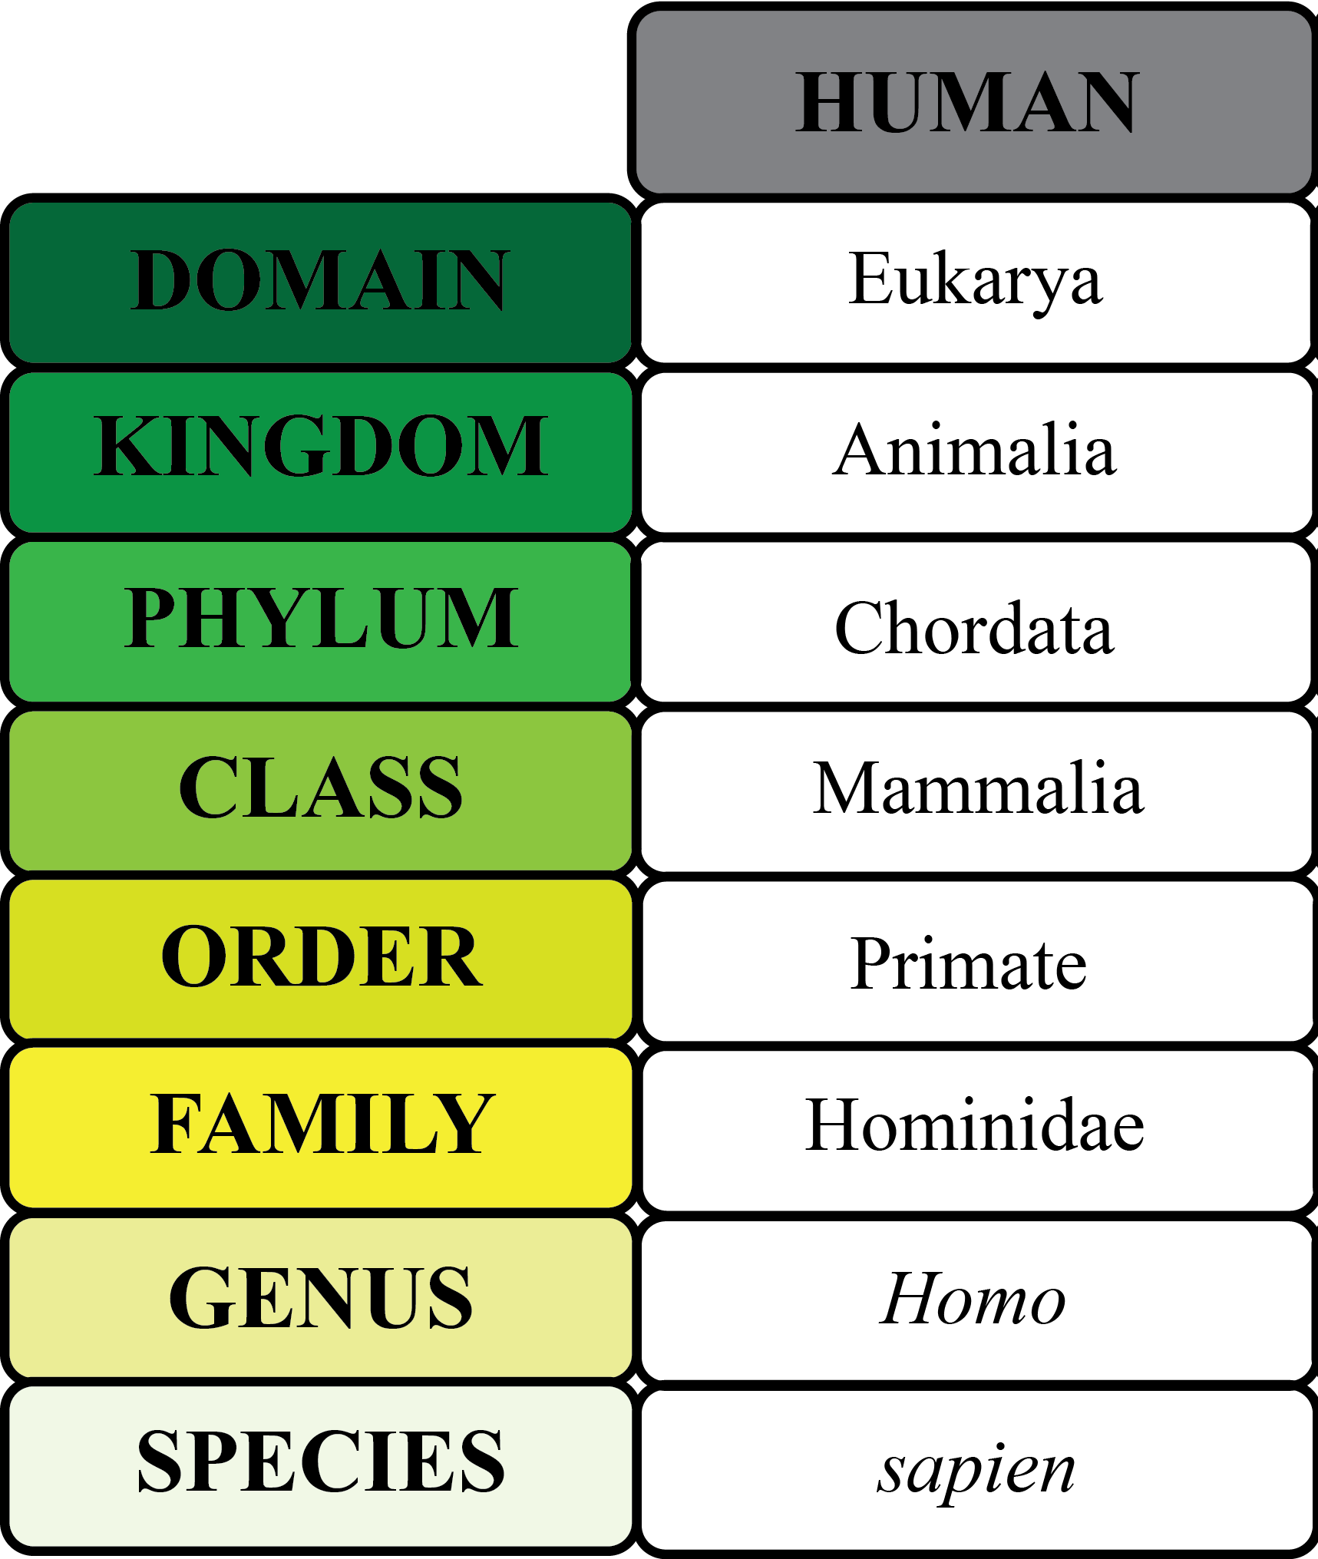
KINGDOM: __________________________________________________
____________________________________________________________
SPECIES: organisms that are similar in structure and appearance, can breed successfully, and have the same number of chromosomes.

VARIETIES or BREEDS:

10:3 Binomial Nomenclature
Linnaeus also introduced a system of naming organisms called
- In binomial nomenclature the name is the to which the organisms belongs, the name is the name of that organism.
- The genus name is , the species name is case.
- are always underlined or italicized.
EXAMPLE→
(man)
Linnaeus used Latin names because:

EXAMPLES of scientific names→
→ domestic dog
→ wolf
→ coyote
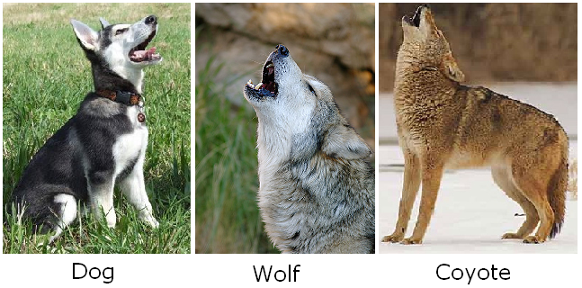
Common names are confusing because:

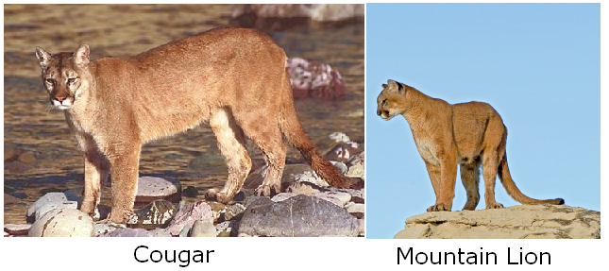
Common names:
Scientific name:

10.4 Modern Taxonomy
- Modern taxonomy is based on and the theory of .
- If two organisms have the same number of chromosomes and the chromosomes are similar in form, then the organisms are closely related
- The greater similarities in DNA, the between organisms.

The THREE DOMAINS:

DOMAIN ARCHEA: (Kingdom Archeabacteria)

DOMAIN BACTERIA: (Kingdom Eubacteria)

DOMAIN EUKARYOTE:
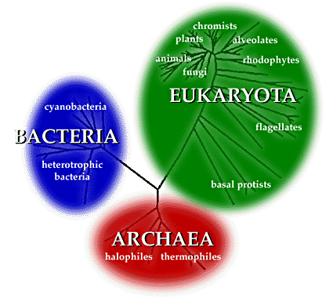
The FOUR KINGDOMS of the DOMAIN EKARYOTA
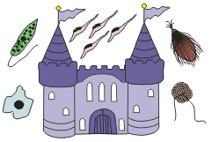
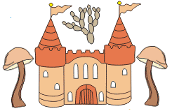

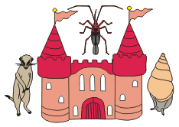
KINGDOM PROTISTA:

KINGDOM FUNGI:

KINGDOM PLANTAE:

KINGDOM ANIMALIA:

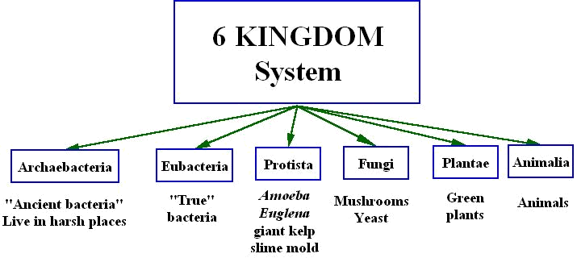

10:5 Phylogenetic Trees and Cladograms
PHYLOGENY: _______________________________________________
________________________________________________________________________________________________________________________
PHYLOGENTIC TREE:_________________________________________
________________________________________________________________________________________________________________________
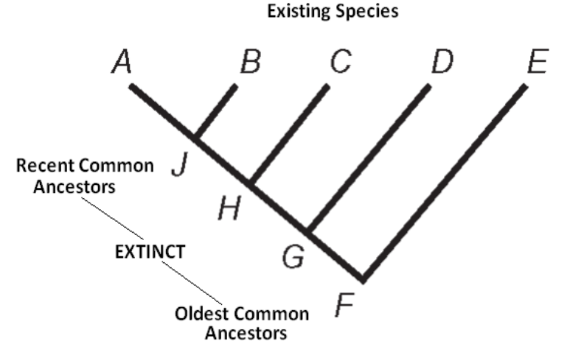
RECENT

PAST

Phylogenetic Trees show which organisms are ____________________ and which are ____________________. It also gives the relative ________________ when the organisms were alive.
CLADOGRAM:________________________________________________________________________________________________________________________________________________________________________

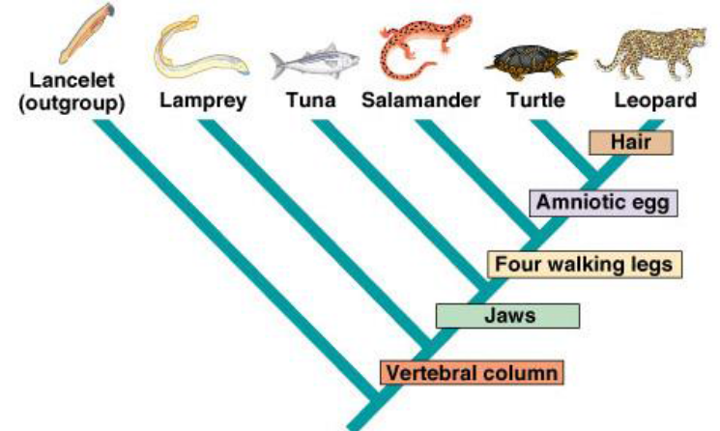
Derived characteristics appear at _______________________________
______________________________________________________________

Cladograms DO NOT _______________________________
______________________________________________________________

