Biology Unit 6 Chromosomes and Mitosis

6:1 Chromosomes
→ →

CHROMOSOMES/CHROMATIN are made of units called GENES are made of a compound called

GENE:

CHROMATIN:
DNA must be in chromatin form

CHROMOSOME:
DNA must be in chromosome form

DNA is replicated in chromatin form Chromatin then changes to chromosomes When chromatin forms into chromosomes, the chromosomes appear
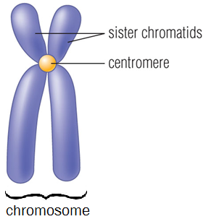
CHROMATID (SISTER CHROMATID):
CENTROMERE:

DNA in Prokaryotes
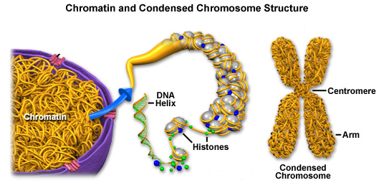
- Bacterial DNA is ____________
- Have _______________________
- No nucleus, __________________
____________________________

6:2 Chromosome Number
Every species has a characteristic number of chromosomes which is different from other species.
Example: nematode worm
protozoan
human

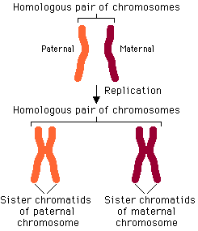
Chromosomes occur in in sexually reproducing organisms. One of the pair comes from the , the other comes from the

HOMOLOGOUS CHROMOSOMES:

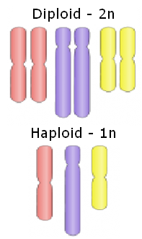
DIPLOID (2N):
Diploid or 2N number in humans is

HAPLOID (1N):
Haploid or 1N number in human egg or sperm is

SEX CHROMOSOMES:

Females have _________

Males have _______

AUTOSOMES:
KARYOTYPE:
- First 22 are __________________________
- Last 2 are ___________________________

6:3 Cell Division in Prokaryotes
ASEXUAL REPRODUCTION: ___________________________________
________________________________________________________________________________________________________________________
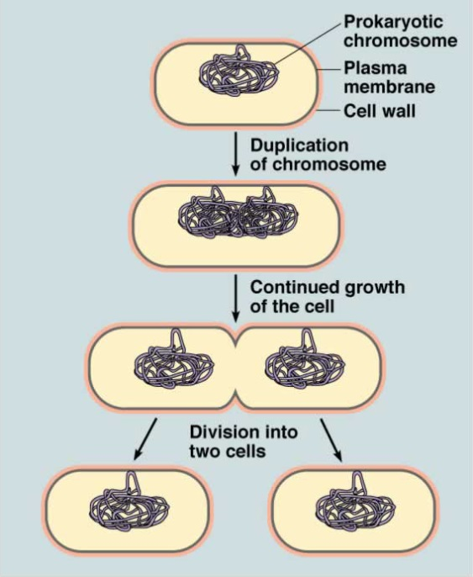
- Example:
  - BINARY FISSION:

- The __________ is __________, resulting in ________ identical chromosomes attached to the inside of the ____________________________.
- The cell grows until it reaches approximately _____________________________________________________________________________.
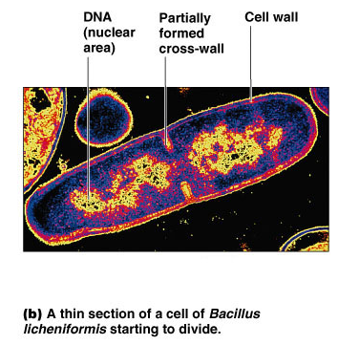
- The growing cell membrane pushes __________ and the cell is _____________________ at the center.
- A ____________ cell wall forms around the ________________________.

6:4 Cell Division in Eukaryotes

ASEXUAL REPRODUCTION: production of offspring from one parent

Example:

MITOSIS:

SEXUAL REPRODUCTION: reproduction in which sex cells from two parents unite

Examples:

MEIOSIS:

CELL CYCLE:
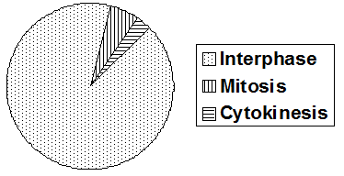
EVENTS OF THE CELL CYCLE:

The Cell Cycle is a ; cells are
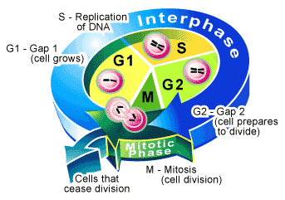
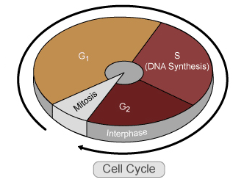

6:5 Interphase

INTERPHASE:

Events of Interphase:
- The cell spends most of its life in __________________
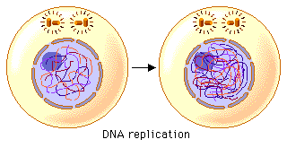
- 3 phases of Interphase:
  - G₁ Phase:
    - Cells grow ___________________
    - DNA is in ____________________ form, spread throughout the ________________
  - S phase:
    - Synthesize (______________) DNA, cell will contain 2 exact copies of each chromosomes
  - G₂ phase:
    - Prepares for ___________________________
    - Grows __________________
    - Makes ___________________ needed for cell division
- Some cells enter G₀ phase:
  - Cells do _________ copy their _______ and do not prepare for _______________________
  - Exit the cell cycle after ____________
  - Examples: fully developed cells in the _____________________________, _______________________

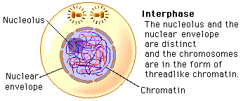

6:6 Mitosis
MITOSIS:

PARENT CELL:
DAUGHTER CELL:
Mitosis must be very to exactly divide the replicated chromosomes
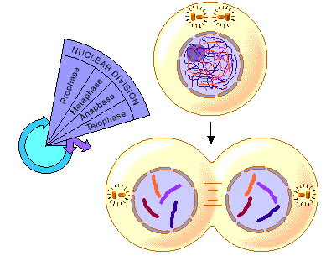
FOUR PHASES OF MITOSIS
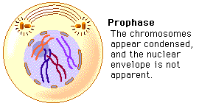
1. PROPHASE→
- 1st dividing phase
- ______________ move to opposite sides of cell
- Chromatin coils into __________________
- ______________________ and _________________ disappear
- _________________ form from microtubules and attach to _________________________
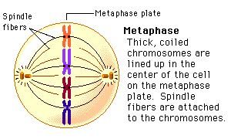
2. METAPHASE→
- Spindle fibers _______________ to paired ___________________________________
- Chromosomes (____________________________) move to the equator (_____________ of the cell)

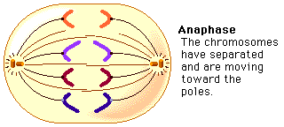
3. ANAPHASE
- ______________________ split
- Chromatids are now considered to be ___________________________
- Spindle fibers shorted and pull the _____________________ ___________ to opposite poles of the cell

4. TELOPHASE→
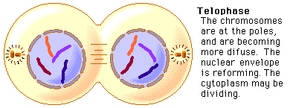
- Centrioles and spindle fibers ___________________
- Chromosomes unwind into _________________
- Nuclear membrane forms around ___________ masses of chromatin
- ______________________________

MITOTIC PHASE CHROMOSOMES SPINDLE

6:7 Cytokinesis

CYTOKINESIS:
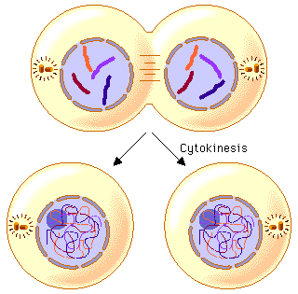
Events of Cytokinesis:
- Immediately follows _______________
- __________________ from original parent cell splits to form __________ new cells
- Each ____________ cell contains one of the _______________ formed by ________________
- Other _______________________ are evenly distributed into __________ new, equally sized cells.

DIFFERENCES IN CYTOKINESIS - PLANT versus ANIMAL
ANIMAL →

PLANT →
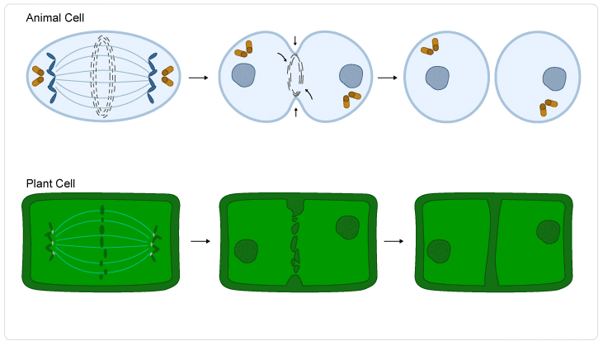

Summary of Events in the Cell Cycle
- ____________________________
  - ____________________________
  - ____________________________
  - ____________________________
- ____________________________
  - ____________________________
  - ____________________________
  - ____________________________
  - ____________________________
- ____________________________

6:8 Meiosis
- SEXUAL REPRODUCTION: reproduction in which sex cells from two parents unite
  - Examples:
    - MEIOSIS: a process in cell division during which the number of chromosomes decreases to half the original number (haploid) by two divisions of the nucleus, which results in the production of sex cells

Advantages of Sexual Reproduction:
- Allows for ______________ in _________________
- Individuals can be ____________________
- Provides foundation for ___________________
- Allows species to ________________ to changes in their environment

Steps of Meiosis
- Meiosis I
  - Prophase I:
    - DNA coils tightly into ____________________
    - SYNAPSIS:__________________________________________________________________________________
    - TETRAD: ______________________________________
______________________________________________
    - Chromatids twist around __________________________
    - CROSSING-OVER: _____________________________
____________________________________________________________________________________________
- Metaphase I:
- _____________________ line up randomly along the center of the cell
- __________________________________ from one pole attach chromosomes
- Anaphase I:
- Each ____________________________________ moves to an opposite pole of the dividing cell
- INDEPENDENT ASSORTMENT: ___________________
______________________________________________
- Telophase I and Cytokinesis I
- __________________________________ reform
- The cell separates into ______________________
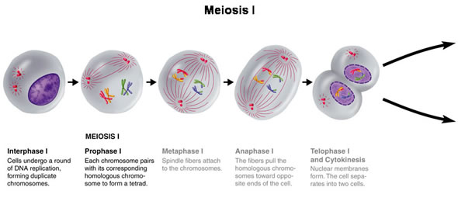

- Meiosis II
  - Prophase II
    - ________________________________________
    - Spindle fibers _________________________
  - Metaphase II
    - ________________________ move to the __________________ of the cell (similar to mitosis)
  - Anaphase II
    - _____________________ separate and move toward ____________________ poles of the _______________
  - Telophase II and Cytokinesis II
    - __________________________ forms around the ________________ of the _________ new cells
    - ____________________ occurs, results in __________ haploid cells (1n)

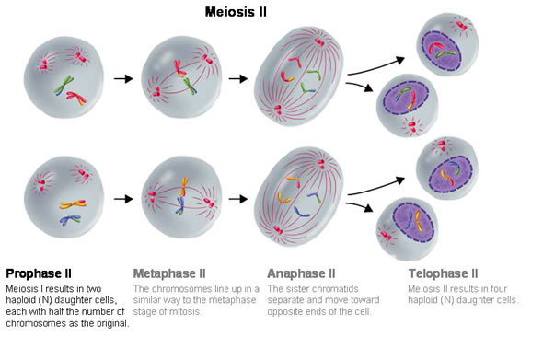

Meiosis produces that fuse during fertilization to form

Differences between Mitosis and Meiosis:
 | Meiosis | Mitosis
Type of Reproduction
Genetically
Crossing Over
Pairing of Homologous Chromosomes
Function | Genetic ______________ through sexual reproduction | Cellular reproduction and general growth and repair of the body
# of Divisions
# of Daughter Cells
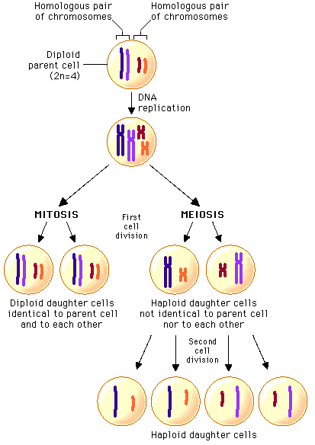

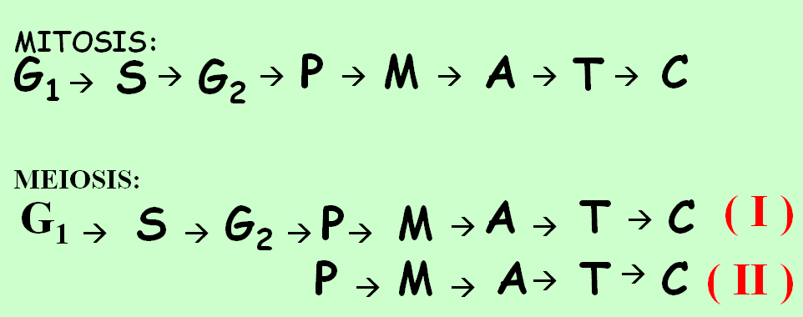

6:8 The Development of Gametes
SPERMATOGENSIS: __________________________________________
____________________________________________________________

OOGENESIS: ________________________________________________
____________________________________________________________

POLAR BODY: _______________________________________________
____________________________________________________________

Steps of Sexual Reproduction



