Biology Unit 8 Evolution
8:1 Life comes from Life
bio – genesis – a –

BIOGENESIS:

ABIOGENESIS (spontaneous generation):
EX:

JOHN NEEDHAM: English scientist whose experiments supported abiogenesis

Needham’s Experiment
- Different meat and vegetable broths were boiled a FEW minutes, then the open flasks were cooled to room temperature.

- Needham concluded since killing microbes

Needham’s Flaws
- 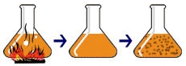Broth was not
- Because they were not

These flaws allowed to challenge Needham’s conclusion.

LAZZARO SPALLANZANI: Italian scientist and biogenesis supporter who tried to disprove Needham’s conclusions

Spallanzani’s first experiment
- 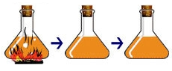 Tightly sealed flasks of broth
- After several days microscopic examination showed
- Spallanzani concluded

Abiogenesis supporters said

Spallanzani’s second experiment

  - Set 1 –
  - Set 2 –
  - Set 3 –
  - Set 4 –

- Spallanzani found more microbes in the flasks boiled longest because boiling removes water and enriches food.
Francesco Redi and Louis Pasteur did experiments

REDI’S FIRST EXPERIMENT
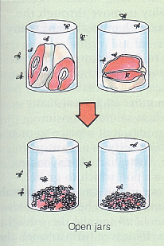Hypothesis –

Control sample –
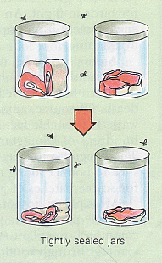

Experimental sample –

Experimental factor(s) – no flies could enter experimental jars, also no air could enter
Results – Maggots formed in control (open) jars, no maggots formed in experimental (sealed) jars
Conclusion –

Redi’s first experiment was faulty due to 2 experimental factors. Supporters of abiogenesis said air had to circulate in the jars to allow the meat to change to maggots.

REDI’S SECOND EXPERIMENT
Hypothesis and Control sample –
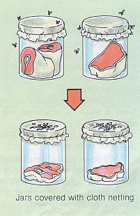
Experimental sample –
Results –
Conclusion –

Even after Redi disproved abiogenesis of multicellular organisms, some scientists still tried to prove microorganisms were produced by abiogenesis because with microscopes they saw microbes in broth and sugar solutions.
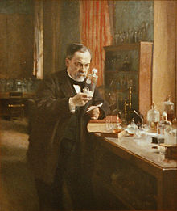
LOUIS PASTEUR:

Pasteur hypothesized microbes were found in air on dust particles.

Pasteur’s first experiment
- Sealed flasks of broth were boiled long enough to
- Flasks were opened in different areas where the amount of
- After microscopic examination a few days later the flasks opened in dusty areas showed more microbial growth than those opened in less dusty areas.

Pasteur’s second experiment
- 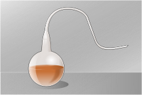 Broth was placed in flasks and the necks of the flasks were
- Flasks were boiled, killing microbes and forcing air out of the flasks,
- Air re-entered flasks as they cooled. If dust could fall into the broth microbes grew. If dust could not enter the
8:2 What is Evolution?
EVOLUTION:

Individual organisms
but they do not

POPULATION:
SPECIES:

Populations exist over much longer than

The process of evolution involves
Evolution has occurred on Earth

JEAN BAPTISTE LAMARCK:

Example:

8:3 Changes in Genes
GENE:
If the population’s changes, then

MUTATION:

Two Types of Mutations:
- Changes in genes in body cells:
- Changes in genes in gametes (egg and sperm):
Mutations may result in a trait that so that organism would be
Then the favorable mutation would be
This results in

Mutations occur so populations evolve

8:4 Changes in a Population’s Environment
ADAPTATION:

If a population’s environment changes,
Adaptations that help the organism survive
GEOGRAPHIC ISOLATION:
EX:

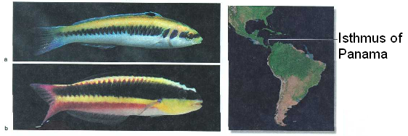
(A) Blue-headed wrasse (Atlantic side of Isthmus) and (B) Cortez rainbow wrasse (Pacific side of Isthmus) are related by descent from a common ancestral population that split when the Isthmus formed.
Populations may also divide
Over time, different mutations may form in each population, so
Eventually, the populations may form

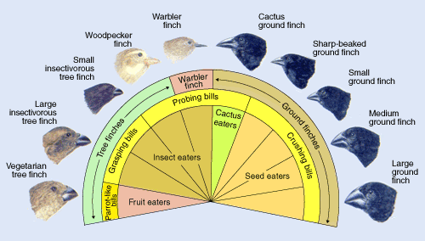
All of the bird species pictured above evolved from a common ancestor. The populations were separated from each other on different islands.

8:5 What do Fossils Show?
FOSSIL :
FOSSIL RECORD:

The fossil record shows how shows that the Earth is about
The fossil record shows that some species

EXTINCT:
EX:

Extinctions occur when
The fossil record helps scientists to discover

8:6 What is the Theory of Evolution?
SCIENTIFIC THEORY:

Theories explain
If scientists find new evidence that contradicts the theory,

HYPOTHESIS:

CHARLES DARWIN:
- Traveled on the
- Noticed the locations of similar organisms around the world

DARWIN’S TWO THEORIES
- Descent with Modification:
EX:
- Natural Selection:

How does evolution occur through natural selection?

Example of Natural Selection:

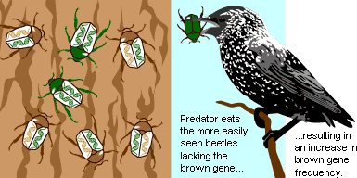

8:7 Types of Natural Selection
FITNESS:

The greater the fitness of the individual,

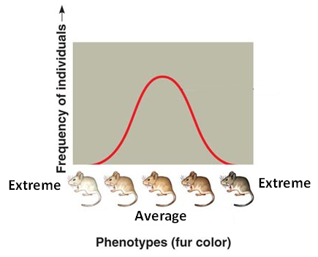
Individuals in a population
Most individuals will exhibit the

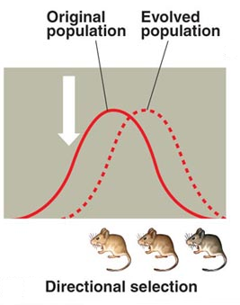DIRECTIONAL SELECTION:
Directional selection is

Changes in

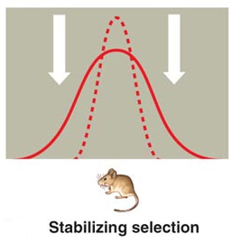STABILIZING SELECTION:

Stabilizing selection

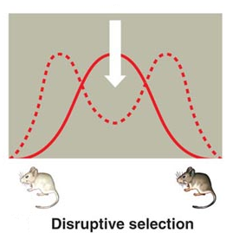DISRUPTIVE SELECTION:

Disruptive selection, like directional selection,
Disruptive selection differs

