Directions: Read Section 1 Classifying Matter and answer the questions below.
- What two properties does all matter have?

- Look closely at the picture on page 23 of the reading. What can you see in this picture that is not matter? Explain your answer.

- Fill in the graphic organizer to show the three main groups of matter.
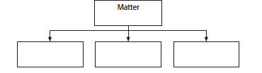

- How are atoms and molecules related?

- A particular molecule has two hydrogen atoms and two oxygen atoms. How do you know that this not a molecule of water?

- How many total atoms are in three molecules of table sugar?

- Use a periodic table to label the elements in a molecule of indigo. C₁₆H₁₀N₂O₂

- What two kinds of matter are pure substances?

- How are mixtures and pure substances related?

- How do homogeneous and heterogenous mixtures differ?

- Generally, you must stir a can of paint before you use it. Is paint miscible or immiscible? Explain your answer.

- Why is Co an element, but CO a compound? (Hint: Use a periodic table to answer this question.)

Define the following terms:
- Atom

- Compound

- Element

- Matter

- Mixture

- Molecule

- Pure substance

Fill in the concept map below to show the relationship between the following: compound, element, mixture, pure substance.

