Biology Spring Semester Review
Cellular Respiration
- A cell has enough available ATP to meet its needs for about 30 seconds. What is likely to happen when an athlete exhausts his or her ATP supply?

- Name the energy-containing products of glycolysis.

- Name the electron carriers in the citric acid cycle.

- Where are the proteins of the electron transport chain located?

- During aerobic respiration, what molecule directly donates electrons to the electron transport chain at the lowest energy level?

- What process generates a proton-motive force in mitochondria?

- How many molecules of ATP are produced from one molecule of glucose in aerobic cellular respiration?

DNA/RNA PROTEIN SYNTHESIS
- Each organism has a unique combination of characteristics encoded in molecules of _______________.

- Explain the significance of each of the following scientists:
  - Watson and Crick:

  - Fredrick Griffith:

  - Rosalind Franklin:

  - Erwin Chargaff:

- Describe the function of DNA.

- Describe the function of tRNA.

- What are the base pairing rules in DNA?

- What would be the complementary strand to CCTAGCTA in DNA?

CELL CYCLE
- Define each of the following words:
Chromatids –

Centromere –.

Crossing over –

Tetrad –

Diploid cell –

- Human Chromosomes numbers?
Diploid number:

Haploid number:

Sex chromosomes:

Autosomes:

GENETICS
- Who is the “father” of genetics?

- Define the following words:
Heredity –

Punnett Square –

- Purple flowers in pea plants are dominant to white flowers in pea plants. Write the genotype for:
Homozygous Dominant flower pea plant

Heterozygous flower pea plant

Homozygous Recessive flower pea plant

- Cross a heterozygous tall pea plant with a heterozygous tall pea plant and give the genotype and phenotype of the offspring.

- According to the law of incomplete dominance, if R is red and W is white, what would flower with the genotype RW look like?

EVOLUTION
- What do scientists believe that the first cells resembled?

- Define the following words:
Adaptation –

Divergent evolution –

Theories –

- The picture below shows Darwin’s finches. What drove the speciation of these finches?
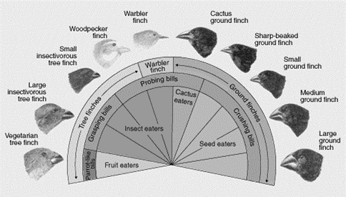

- Who developed the system of classifying organisms by assigning them a genus and species name?

- What is the correct order of the biological hierarchy from kingdom to species?

- A domestic dog is also known as Canis familiaris.
What is this organism’s genus?

What is this organism’s species?

What is the scientific name?

- Define derived character.

ECOLOGY
- Define the following words:
Ecology –

Community –

Ecosystem

Habitat –

Producers –

Ecological succession

Primary Succession

Secondary succession

Commensalism

Competition

Mutualism

Parasitism

Carrying capacity

Exponential growth pattern

Pioneer species

