This study guide is meant to be a review over concepts taught and applications practiced. Your test may be a few knowledge/comprehension but the majority will be application/analysis and synthesis/evaluation questions.
- You are responsible for the terms on the “Ecology Pre-assessment”.

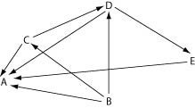

Using the food web above, identify producers, primary consumers.

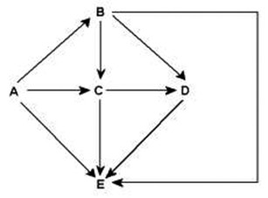
Using the food web above, identify producers, herbivores, omnivores, carnivores, decomposers.

- What are the parts of an ecosystem? ______________________________________________________

- In a pyramid of energy, how much energy does the next higher feeding level receive? __________ How much energy is used or lost as heat? ____________

- In a pyramid of energy, how many organisms does the next higher feeding level have? _________

- What is a trophic level? ________________________________________________________________
  - Which trophic level are the following organisms found in?
    - Producers: __________________________________

    - Herbivores: _________________________________

    - Carnivores/Omnivores: __________________________________________________

- What is symbiosis: ____________________________________________________________________

____________________________________________________________________________________
- What are the three types of symbiosis? Be able to recognize an example of each.

  - Mutualism: ____________________________________________________________________

  - Commensalism: ________________________________________________________________
______________________________________________________________________________

  - Parasitism: ____________________________________________________________________
______________________________________________________________________________

- Compare and contrast the terms fundamental niche and realized niche. ___________________________

____________________________________________________________________________________

____________________________________________________________________________________
- What happens to a food chain when you remove one of the organisms? (How will it affect the organisms
it feeds on and the organisms that feed on it?) _______________________________________________

____________________________________________________________________________________

