Cellular Respiration
- What metabolic pathway is common to both fermentation and cellular respiration of a glucose molecule?

- For each mole of glucose (C₆H₁₂O₆) oxidized by cellular respiration, how many moles of CO₂ are released? How many ATP?

- Most CO₂ is released during which catabolic reaction?

- What is the final electron acceptor of the electron transport chain that functions in aerobic oxidative phosphorylation?

- What are the products of glycolysis?

- What is the product of pyruvate oxidation?

- Be able to read the diagram to answer questions.
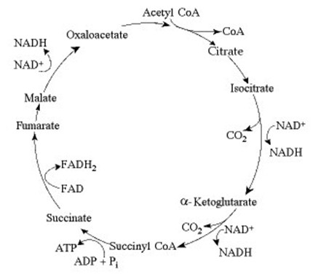

DNA & RNA, Protein Synthesis
- What is the central dogma of biology and what are the processes involved?

- What are Chargaff’s two rules?

- Scientists did experiments to determine if DNA or protein was the genetic material.
Explain what the scientists discovered and their experiments.
Griffith

Hershey and Chase

- Define Antiparallel.

- Define Transcription.

- Define Translation.

- Use the diagram to answer the following question.

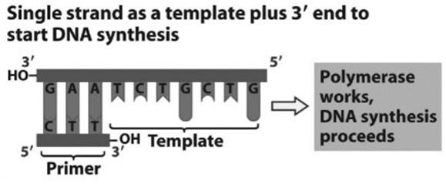
Referring to the figure, what bases will be added to the primer as DNA replication proceeds?

- Semiconservative replication requires a template. What is the template?

- The genetic code is reduntant. What does that mean?

- What is the function of the enzyme topoisomerase in DNA replication?

Cell Cycle
- Describe the major events that occur in each phase of the somatic cell cycle. Specifically include what form/position the genetic material is in and various structures (centrioles, nucleus, mitotic spindles).
Interphase-

G1-

S-

G2-

Mitosis-

Prophase-

Prometaphase-

Metaphase-

Anaphase-

Telophase/Cytokinesis-

- Describe differences of cell division in animal and plant cells.

- A pig’s somatic cell has 38 chromosomes. How many chromosomes did the pig inherit from each parent? How many are in its gametes? How many are in its somatic cell after S phase?

- Complete the following table of chromosome number in various species.
Species | # of chromosomes in diploid cells (2n) | # of chromosomes in haploid cells (n)
Fruit fly |  | n=4
House fly | 2n = 12
Rice |  | n = 12
Petunia | 2n = 14

- Define genome.

- Define karyotype.

- Describe the major events that occur in each phase of the gamete cell cycle. Specifically include what form/position the genetic material is in and various structures (centrioles, nucleus, mitotic spindles).
Interphase-

G1-

S-

G2-

Meiosis-
Meiosis I
Prophase I -

Metaphase I -

Anaphase I -

Telophase I/Cytokinesis I –
Meiosis II
Prophase II

Metaphase II

Anaphase II

Telophase II/Cytokinesis II -
Genetics
- Explain the difference between monohybrid and dihybrid crosses.

- Know how to work a Monohybrid cross, a Dihybrid cross, codominance and incomplete dominance, ABO blood groups, pedigree, X-linked traits

- Why are males more often affected by sex-linked traits than females?

- Generally, only female cats have the tortoiseshell phenotype for fur color. Explain this phenomenon?

- Between what two genes would you expect the highest frequency of recombination.
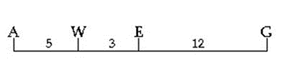

Evolution
- Define adaptations

- Define artificial selection

- Fossils

- Be able to read phylogenetic trees.

Classification
- Which scientist developed the naming system we use today that assigns a genus and species name?

- A domestic dog is also known as Canis familiaris.

What is this organism’s genus? ______________________

What is this organism’s species? _____________________

What is it’s scientific name? __________________________

- What are the seven levels of biological hierarchy in correct order, beginning with Kingdom.

- Be able to read a cladogram and identify derived characters for individual organisms.

- Multicellular, eukaryotic organisms that are plant-like in structure but must obtain food by absorbing nutrients from the environment belong to which kingdom?

Ecology
- Levels of biological hierarchy – organismal, population, community, ecosystem, landscape, global

- Identify the trophic levels of a food web – autotrophs, heterotrophs, primary consumer, secondary consumer, tertiary consumer

- Identify the growth curve for carrying capacity and exponential growth.

- Describe and give examples of the interactions among organisms – predation, commensalism, mutualism, parasitism.

