Biology Unit 7 Name
Mendel’s Experiments Date/Hour

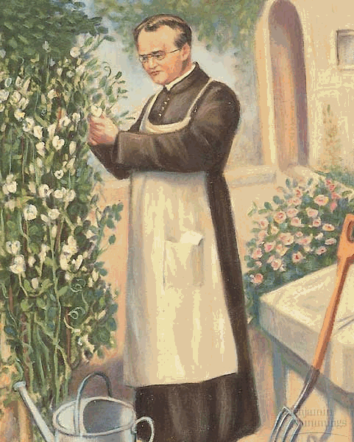
Gregor Mendel was born in 1822 in Heinzendorf, near Austria, and learned his love of gardening from his father who was a farmer. Gregor attended high school in a nearby town. Since his family was so poor and could not afford to pay the full tuition, Gregor received only half the amount of food as the other boys. He nearly starved, and the experience remained in his memory forever. On the advice of a professor he greatly admired, Gregor entered the monastery where he could continue his studies. There he became the caretaker of the gardens and a substitute teacher for an elementary school. From 1856 until 1864, Mendel worked with 10,000 specimen pea plants. He studied seven characteristics of the plants. After eight years of accurate record-keeping, he formulated three laws that became the basis of the science of heredity. He proudly wrote a paper to describe his findings. No one seemed to recognize the genius of his work, though, and Gregor was crushed. In 1883, he died of a heart attack, embittered that no one recognized or appreciated his scientific revelations.

- How many years did Mendel work peas in order to make his discoveries?
- How many different characteristics of peas did Mendel study?

A fair amount about Mendel’s life is known from history, including the fact that some of his lowest grades received in school were in biology. Despite his academic shortcomings, however, Mendel’s work as a scientist uncovered some of the most fundamental concepts of genetics and provided a basis for many of the major advancements in biology that were to come in the following century. That is why Mendel is often referred to as the “Father of Genetics.”

- Why is Mendel referred to as the “Father of Genetics”?
Mendel performed breeding experiments on pea plants by collecting data on the hereditary patterns of a seven different characteristics of the plants, shown below.
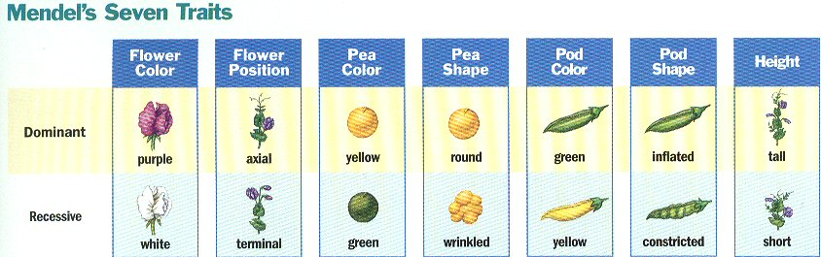
- List the 7 characteristics that Mendel studied along with the dominant and recessive traits for each.
Characteristic Dominant Trait Recessive Trait

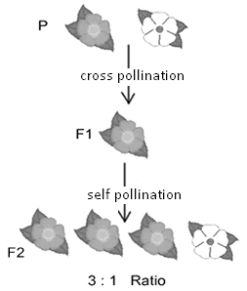
During his first experiment, Mendel cross-pollinated pea plants that were true-breeding for contrasting traits of each characteristic. For example, one of Mendel’s crosses involved breeding plants that always produced purple flowers with plants that were true for white flowers. Mendel called his true-breeding plants the parental generation, or P. The offspring produced by crossing the P generation were called the first filial generation or F₁, for short. The F₁ generation was then allowed to self-pollinate during Mendel’s second experiment, their offspring were the second filial generation, or F₂.

Invariably, the results of the first experiment showed the F₁ generation displayed only one trait, or version of the characteristic, that was present in the parental generation. For example, when Mendel crossed true-breeding purple-flowered plants with true-breeding white-flowered plants, only purple-flowered plants were observed in the F₁ generation. When plants with smooth seeds were crossed with plants with wrinkled seeds, only smooth-seeded plants were observed in the F₁ generation. Mendel called the traits that appeared in the F₁ generation dominant traits. The traits that did not appear in the F₁ generation were called recessive traits. In the diagram below, fill in the dominant and recessive traits and color each.

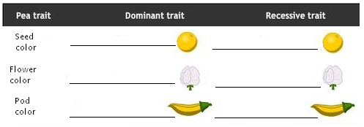
5.

When Mendel allowed the F₁ generation to self-pollinate, the recessive traits reappeared in the resulting F₂ generation. However, as shown in the illustration, the dominant and recessive traits always appeared in the ratio of three dominant to one recessive. Label the illustration below with the following: P generation, F₁ generation, F₂ generation, cross pollination, self pollination. Then color the flowers with the correct trait and answer the questions concerning flower color.
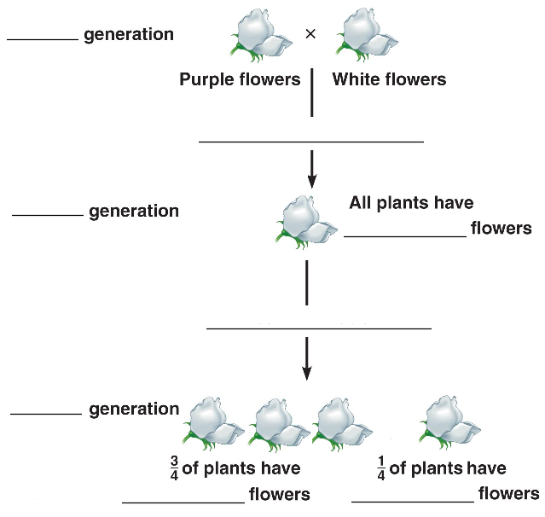
6.

Mendel explained these results by reasoning that each plant had two units of inheritance for any given trait, with one unit coming from each parent. Plants could then theoretically have three possible combinations for a characteristic. They could have two dominant units, two recessive units, or a dominant and a recessive unit. Furthermore, when the adult plants formed gametes – eggs and sperm – through the process of meiosis, each of the units separated so that each gamete carried only one unit. This means that when gametes from separate parents combined and developed into a new plant, the offspring would have one unit of inheritance for a characteristic from each of its parents.

- How many units of inheritance control each trait?
- From where do offspring obtain the units of inheritance?
- How many combinations are possible for each characteristic? What are the possible combinations?
- How many units are in the sperm?
- How many units are in the egg?
Today, we call Mendel’s units of inheritance genes, and the different versions – dominant and recessive – different alleles of the same gene. Different genes are symbolized by letters. The dominant allele of a gene is represented by a capital letter of the dominant trait, while the recessive allele is represented by a lower-case letter of the dominant trait. For example, the gene for flower color is represented by the letter ‘P’. The dominant allele that results in purple color is a capital P and the recessive form that corresponds to white color is a lower case p. An individual’s genotype is shown by the two letters representing the gene. Individuals whose genotypes consist of two of the same alleles are termed homozygous, and are represented as PP or pp, while individuals whose genotypes consist of two different alleles are termed heterozygous, and are represented as Pp. In the diagram below, fill in the genotypes that would result in each type of trait and color each.

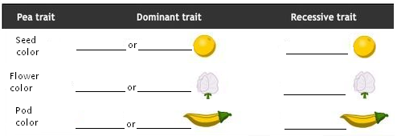
12.

- Mendel’s units of inheritance are now called . The two different versions are different .
- If the two alleles of the gene are both the same, the genotype is .
- If the two alleles of the gene are different, the genotype is .

Mendel’s true-breeding plants, therefore, were homozygous for certain characters, such as flower color. When these homozygous parental plants produced gametes, true-breeding or homozygous dominant parents would produce gametes that all contained one dominant allele. True-breeding or homozygous recessive parents would produce gametes that all contained one recessive allele. When gametes from two homozygous parents combined at fertilization, the resulting offspring would have the heterozygous genotype. The offspring with a heterozygous genotype would express an appearance or phenotype of the dominant trait. This is because the heterozygous F₁ plants carried the dominant allele, which was expressed over the recessive allele.

- A plant homozygous for Purple flowers would have what two alleles?
- A plant homozygous for white flowers would have what two alleles?
- A heterozygous plant would have what two alleles?
- What does phenotype mean?

