SPACE SYSTEMS STUDY GUIDE
Big Bang-Origin of the Universe
- Describe the Big Bang theory?

- What is the age of the universe?

- Describe the evidence for the Big Bang Theory.

- What was Hubble’s evidence that the universe is expanding?

- A galaxy that is moving away from Earth will show what color in the light spectrum?

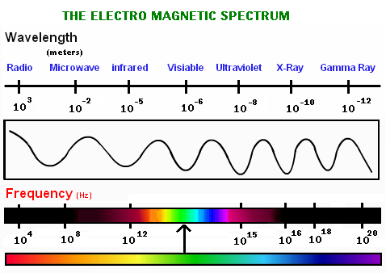
Red Blue
- In red shift, the wavelengths of light become _________________________ (shorter or longer)

- Describe Einstein’s theory on the relationship between mass and space.

- How does Hubble’s Law relate speed and distance of a galaxy?

- Describe the Milky Way galaxy.
Life Cycle of a Star
- What do all stars start as?

- Explain why our sun appears larger than other stars.

- What is a light year?

- What is the relationship between temperature and color of a star?

- The hotter the star, the _____________ the color.

- How can scientists learn about the elements in stars?

- How do scientists know what our sun is made of?

- In the life cycle of stars, what phase will the sun be when it uses up its hydrogen fuel?

- In the life cycle of stars, what phase will the sun end up as?

- Why do massive star have shorter life spans than average stars?

- In what phase of a star’s life cycle will heavier elements form?

- What stage is where a massive star explodes and releases a lot of energy?

- What stage are most stars?

- During which phase does the core of a massive star have so much gravity that even light can not escape?

